Annual ERA-ENVHEALTH
Network Meeting 2015
Brussels, Belgium

Open Conference
NEHAP: National Implementation and Evaluation Processes
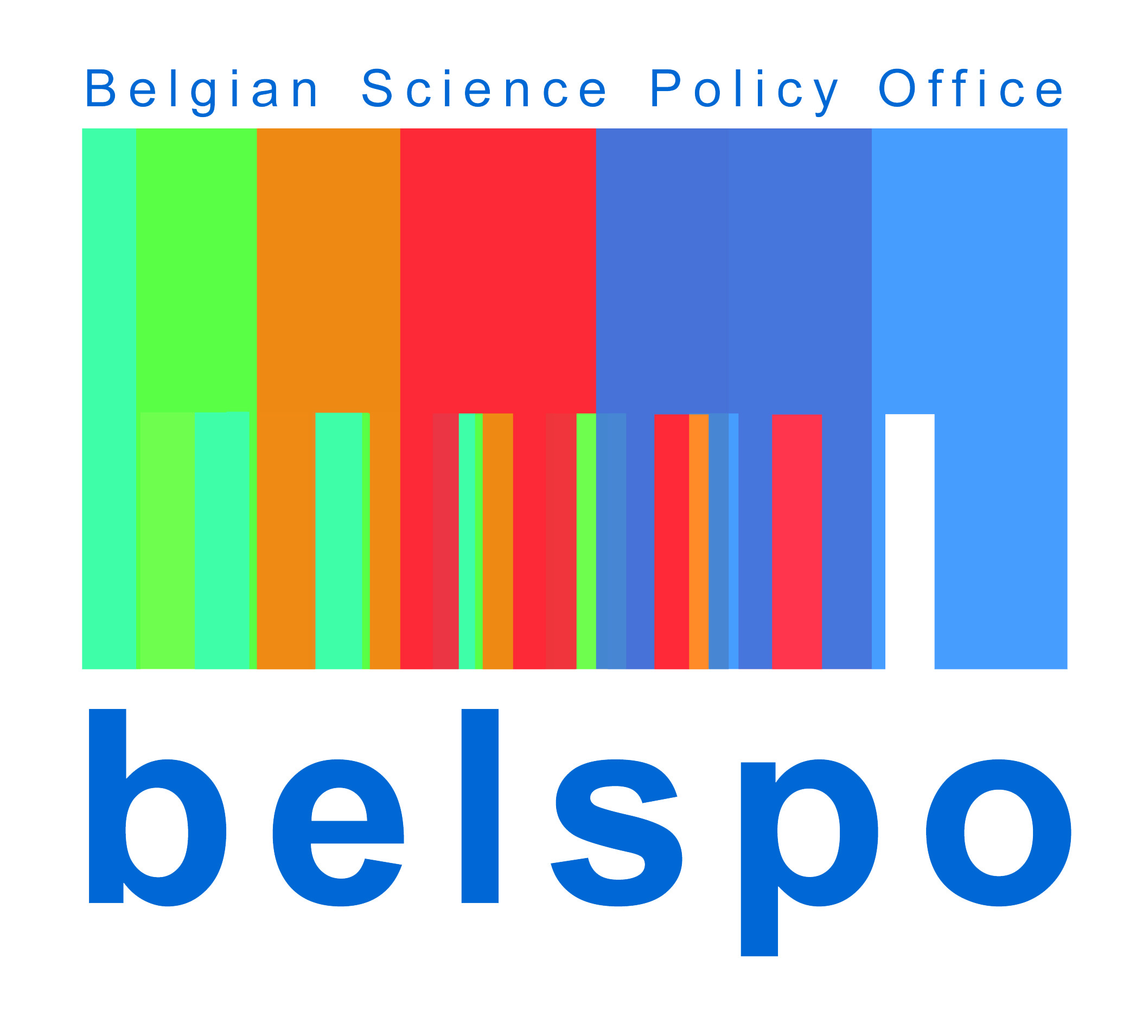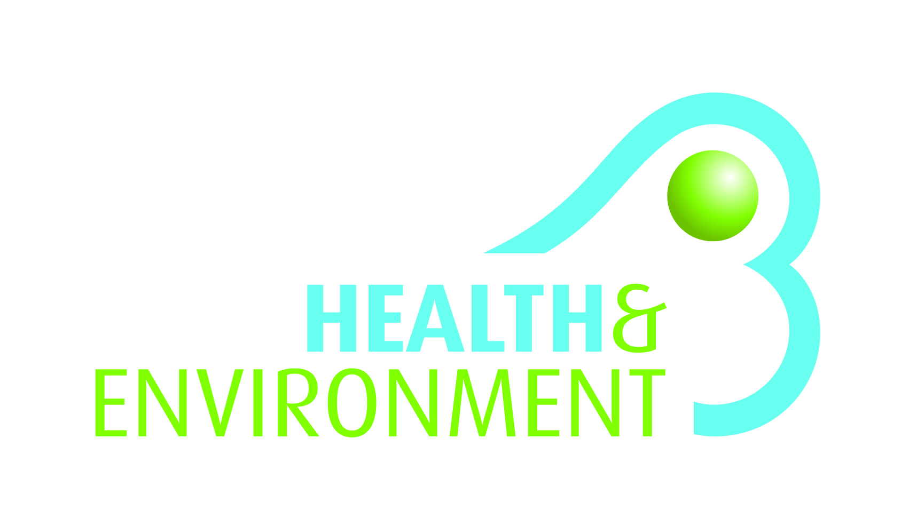
Federal Public Service Health, Food Chain Safety and Environment
Wallonia Public Service
Federal Public Planning Service Science Policy
Belgian National Environment Health
Action Plan

Thursday 22 October 2015
9:00 – 18:00

Location: FPS Public Health
Eurostation II
Place Victor Horta, 40 box 10
1060 Brussels
Bara Room (1st floor)

Morning session
09:00-09:30 Welcome of participants

09:30-09:40 Official Introduction by Dr Dirk CUYPERS, Chairman of the Executive Committee – FPS

09:40-10:10 Francis BRANCART (SPW) “The International & Belgian environment & health process”

10:10-10:40 Coffee break
10:40-11:10 Denis ZMIROU-NAVIER (Inserm) “Evaluation of the Second Health Environment National Plan (PNSE2) 2009-2013: impacts/benefits, evaluation, participatory process and Health Social Inequalities”

11:10-11:40 Liliana CORI (CNR): “Research and actions to support environment and health policies in Italy”

11:40-12:10 P. NICOLOPOULOS_STAMATI (Medical School of National and Kapodistrian, University of Athens) "Health & environment process in Greece"

12:10-12:15 Organization reminder afternoon

12:15-13:30 Lunch

Afternoon session
13:30-15:00 Workshops (in parallel):
- Assessment of the NEHAP implementation process (including definition of the evaluation criteria) - Moderators: Catherine BOULAND (Be) & Marie-Christine DEWOLF (Be)
- The establishment of a participatory process it is desirable and how? - Moderators: Liliana CORI (It) & Ric VAN POLL (Nl)
- Composition and Resources of the process in a context of heightened socio-economic - Moderators: Adrienne PITTMAN (Fr) & Pol GOSSELIN (Be)

15:00-15:45 Coffee Break and compilation of discussions by the moderators
15:45-16:45 General meeting for the presentation of the results of the 3 workshops & general discussion

16:45-17:00 Closing session

